Table 1. Clinical characteristics of the Toronto Adult RMS cohort.

 |  | All (n = 98) | Alveolar  (n = 30) | Embryonal (n = 21) | Pleiomorphic (n = 22) | Spindle cell (n = 4) | RMS, NOS (n = 21) | p-value
Sex |  |  |  |  |  |  |  | 0.26
 | Male | 54 (55.1) | 15 (50.0) | 13 (61.9) | 15 (68.2) | 3 (75.0) | 13 (61.9)
 | Female | 44 (44.9) | 15 (50.0) | 8 (38.1) | 7 (31.8) | 1 (25.0) | 8 (38.1)
Age, median (IQR) |  | 40 (23.25-61.5) | 29.5 (22-35.5) | 23 (20-43) | 58 (48.5-70) | 44.5 (27.25-62.5) | 53 (36-68) | <0.001
Anatomic location |  |  |  |  |  |  |  | 0.002
 | Orbit | 2 (2.0) | 1 (3.3) | 1 (4.8) | 0 (0) | 0 (0) | 0 (0)
 | Parameningeal | 4 (4.1) | 1 (3.3) | 1 (4.8) | 0 (0) | 0 (0) | 2 (9.5)
 | Head/neck (non-PM) | 33 (33.7) | 17 (56.7) | 7 (33.3) | 3 (13.6) | 1 (25.0) | 5 (23.8)
 | Extremity | 22 (22.4) | 3 (10.0) | 2 (9.5) | 12 (54.5) | 3 (75.0) | 2 (9.5)
 | Trunk | 21 (21.4) | 5 (16.7) | 2 (9.5) | 6 (27.3) | 0 (0) | 8 (38.1)
 | Bladder/prostate | 2 (2.0) | 1 (3.3) | 1 (4.8) | 0 (0) | 0 (0) | 0 (0)
 | GU (non-BP) | 14 (14.3) | 2 (6.7) | 7 (33.3) | 1 (4.5) | 0 (0) | 4 (19.0)
Translocation status |  |  |  |  |  |  |  | <0.001
 | Fusion negative | 27 (27.6) | 0 (0) | 13 (61.9) | 8 (36.4) | 1 (25.0) | 5 (23.8)
 | Fusion positive | 29 (29.6) | 29 (96.7) | 0 (0) | 0 (0) | 0 (0) | 0 (0)
 | Unknown | 11 (11.2) | 0 (0.0) | 3 (14.3) | 0 (0) | 0 (0) | 8 (38.1)
 | Not done | 31 (31.6) | 1 (3.3) | 5 (23.8) | 14 (63.6) | 3 (75.0) | 8 (38.1)
Extent of disease |  |  |  |  |  |  |  | 0.006
 | Localized only | 41 (41.8) | 3 (10.0) | 14 (66.7) | 12 (54.5) | 1 (25.0) | 11 (52.4)
 | Lymph node involvement | 29 (29.6) | 13 (43.3) | 3 (14.3) | 6 (27.3) | 2 (50.0) | 5 (23.8)
 | Distant +/- lymph node involvement | 28 (28.6) | 14 (46.7) | 4 (19.0) | 4 (18.2) | 1 (25.0) | 5 (23.8)

Figure 1. Time to progression, including progression and relapse, of the Toronto adult RMS cohort.
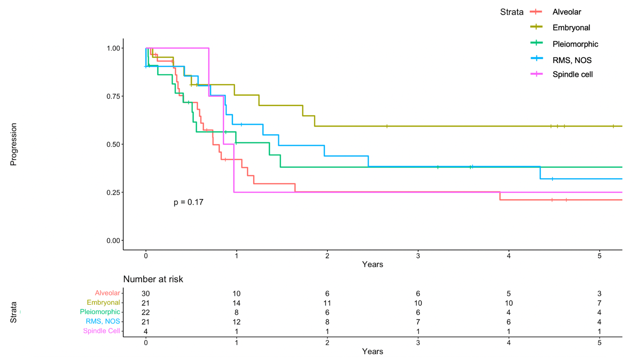

Figure 2. Preliminary genetic drivers of 41 patients from the Toronto Adult RMS cohort

