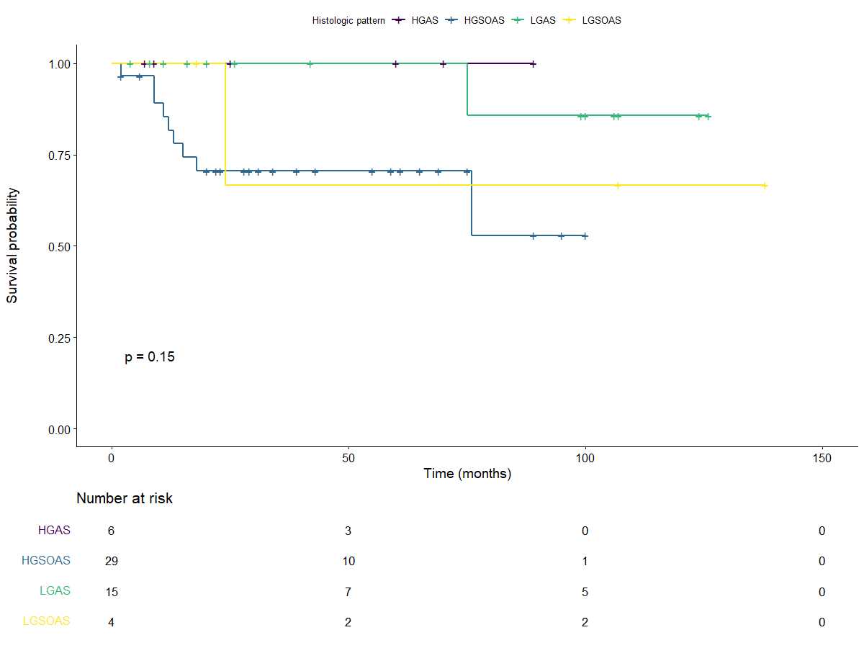

group | Median (95% CI) | Survival rate at 1 years (95% CI) | Survival rate at 5 years (95% CI) | Survival rate at 10 years (95% CI)
HGAS | NA [NA;NA] | 100% [100% ; 100%] | 100% [100% ; 100%] | NA
HGSOAS | NA [76;NA] | 81.7% [68.4% ; 97.6%] | 70.6% [55.3% ; 90%] | NA
LGAS | NA [NA;NA] | 100% [100% ; 100%] | 100% [100% ; 100%] | 85.7% [63.3% ; 100%]
LGSOAS | NA [24;NA] | 100% [100% ; 100%] | 66.7% [30% ; 100%] | 66.7% [30% ; 100%]

Figure 1: Overall survival according to histological groups

