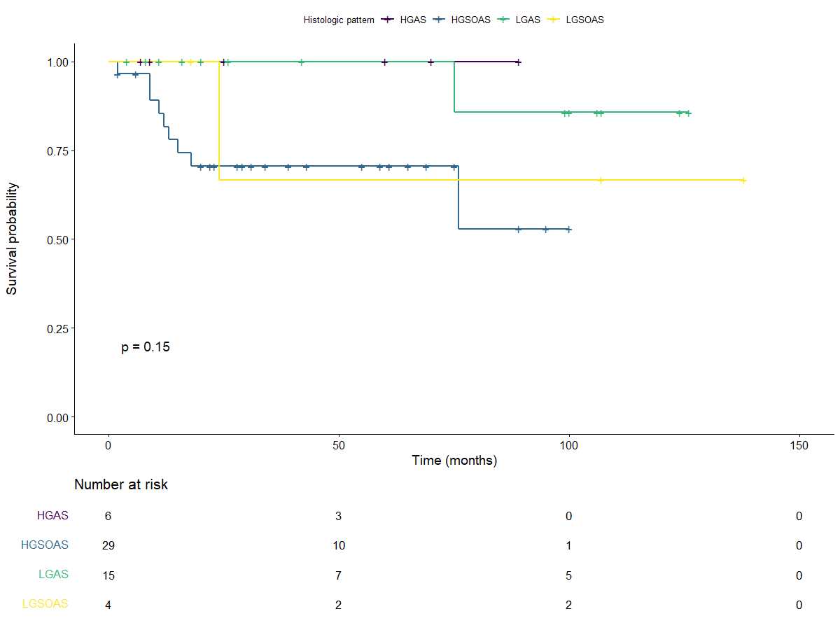

group | Median (95% CI) | PFS rate at 1 years (95% CI) | PFS rate at 5 years (95% CI) | PFS rate at 10 years (95% CI)
HGAS | NA [11;NA] | 75% [42.6% ; 100%] | 75% [42.6% ; 100%] | NA
HGSOAS | NA [18;NA] | 71.6% [56.8% ; 90.4%] | 53.7% [36.7% ; 78.6%] | NA
LGAS | NA [NA;NA] | 100% [100% ; 100%] | 100% [100% ; 100%] | 85.7% [63.3% ; 100%]
LGSOAS | 106 [8;NA] | 75% [42.5% ; 100%] | 75% [42.5% ; 100%] | 37.5% [83.9 % ; 100%]

Figure 2: Progression free survival according to histological group

