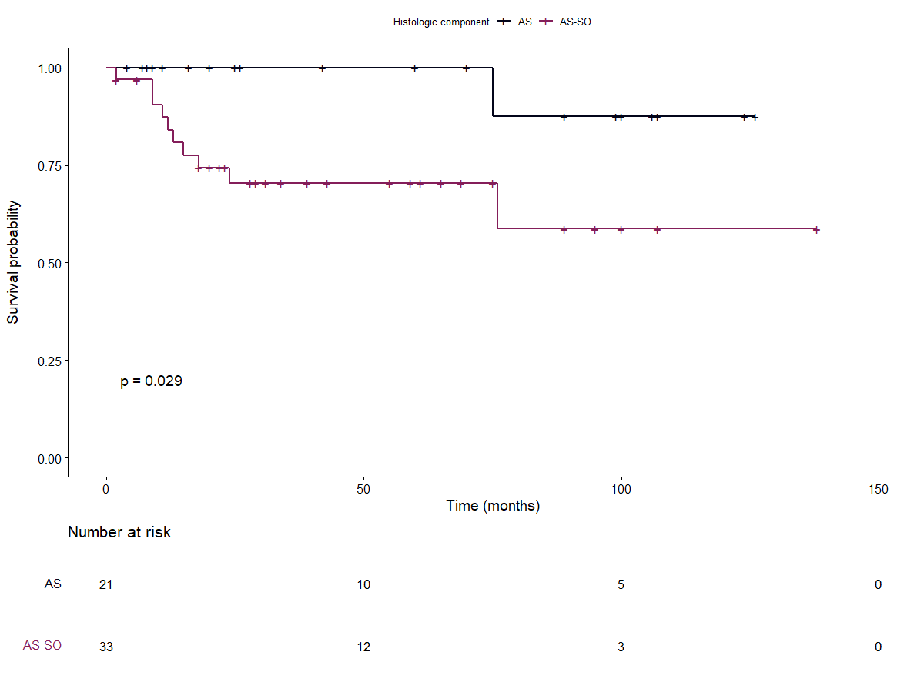

**Figure 3: Overall survival according to sarcomatous overgrowth**