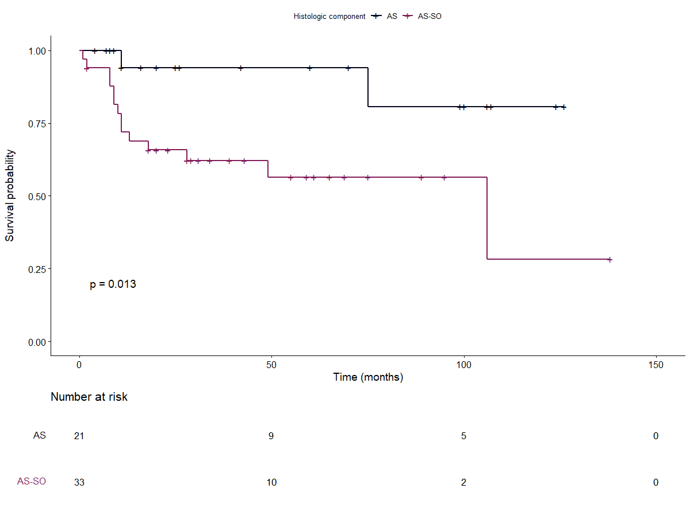

Figure 4: Progression free survival according to sarcomatous overgrowth

