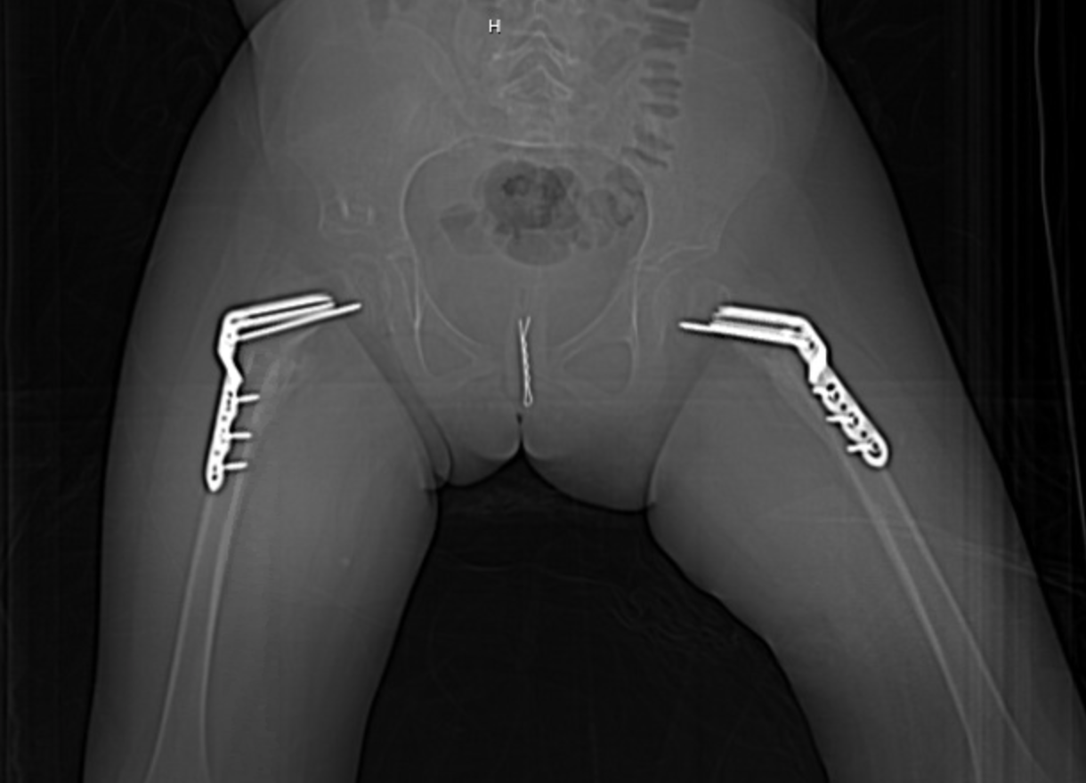
Figure 1 - Pelvis X-Ray

