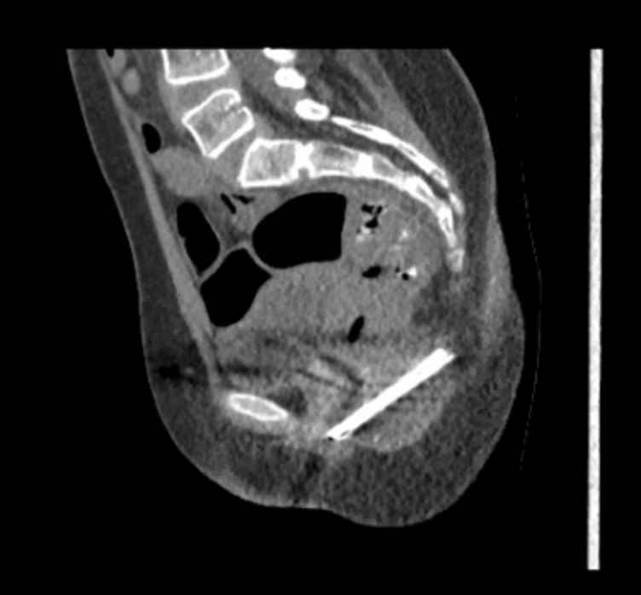
Figure 2 - Sagittal View of Pelvis on Computed Tomography

