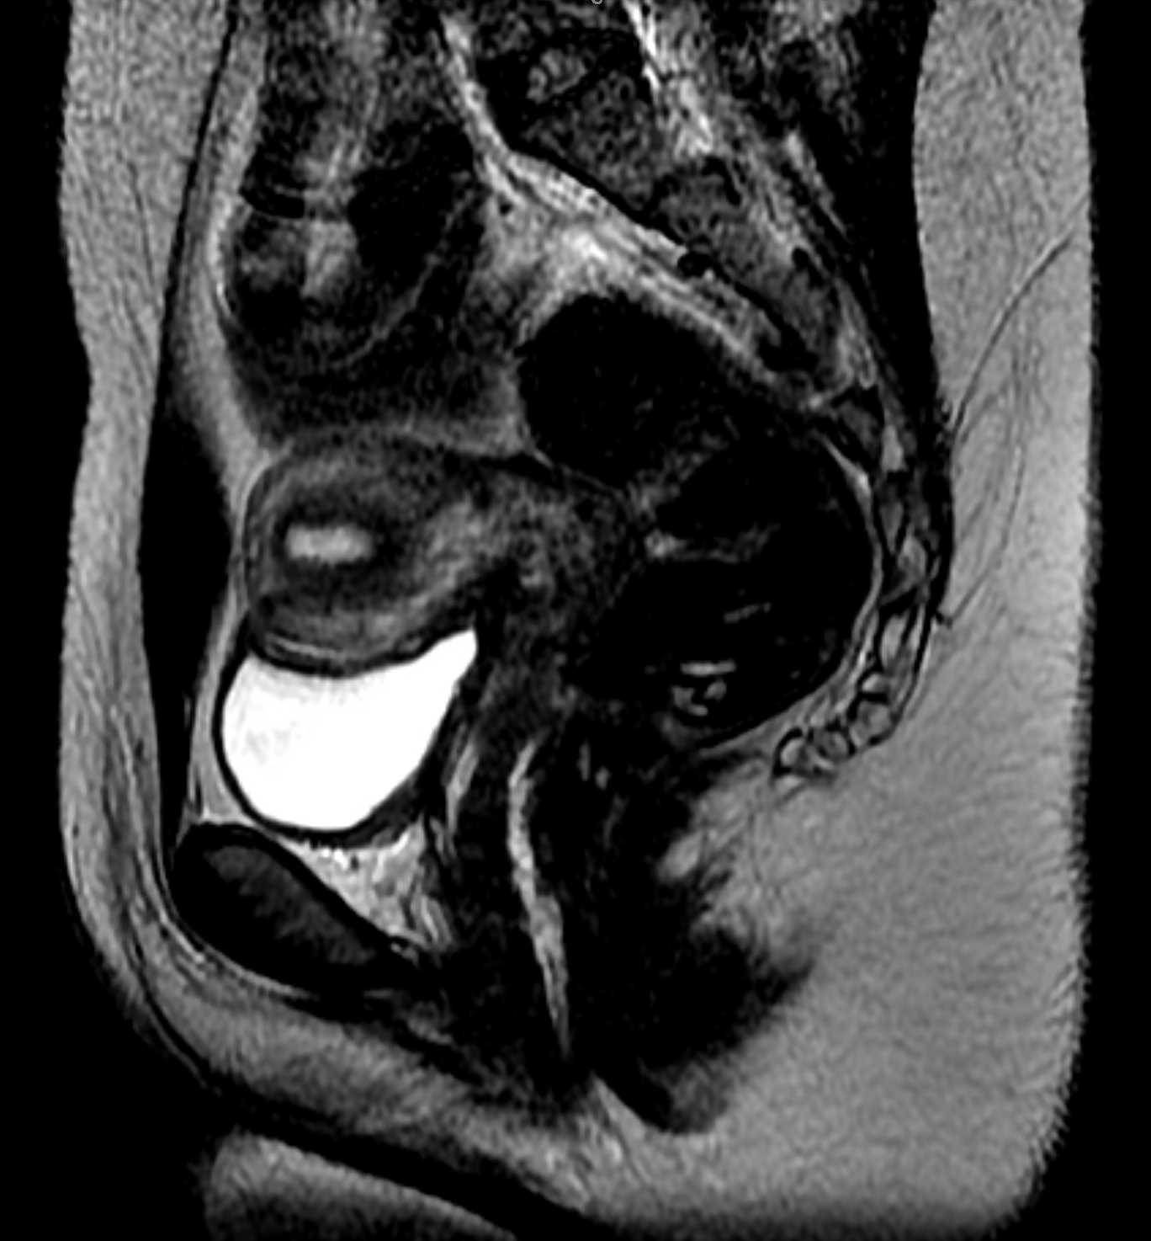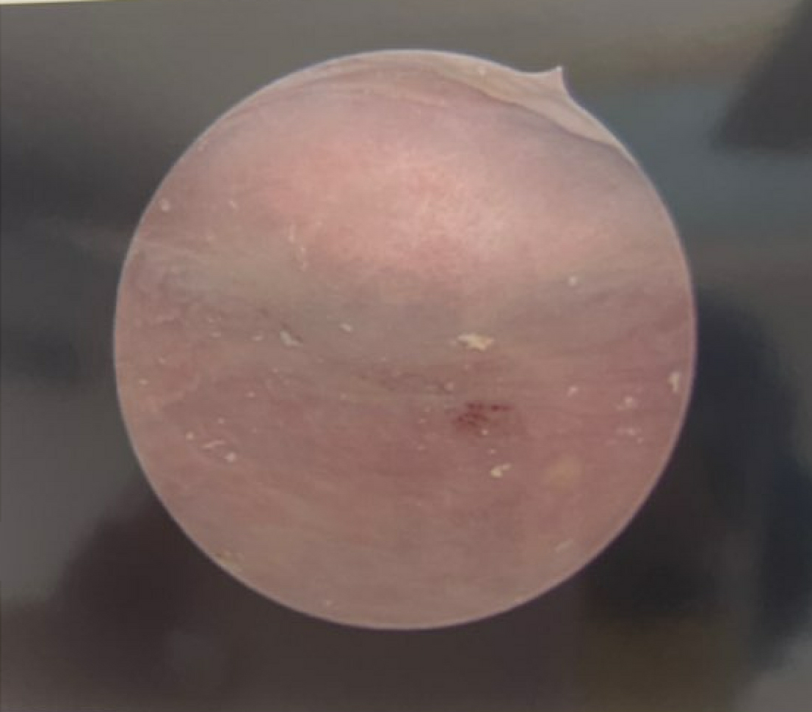
Figure 1 (Left): Sagittal MRI with endometrial canal seen to cut off abruptly at the uterovaginal junction raising concern for rudimentary cervix. Figure 2 (Right): Blind ending vaginal apex protruding 1 cm into the vaginal canal. No cervical os seen
References
1. Lekovich, J. and S.M. Pfeifer, Cervical Agenesis. Congenital Müllerian Anomalies, 2016: p. 55.
2. Markham, S.M., G. Huggins, and T. Parmley, Cervical agenesis combined with vaginal agenesis diagnosed by magnetic resonance imaging. Fertility and sterility, 1987. 48(1): p. 143-145.
3. Mikos, T., S. Gordts, and G.F. Grimbizis, Current knowledge about the management of congenital cervical malformations: a literature review. Fertility and Sterility, 2020. 113(4): p. 723-732.
4. Rock, J.A., C.P. Roberts, and H.W. Jones Jr, Congenital anomalies of the uterine cervix: lessons from 30 cases managed clinically by a common protocol. Fertility and sterility, 2010. 94(5): p. 1858-1863.
5. Casey, A.C. and M.R. Laufer, Cervical agenesis: septic death after surgery. Obstetrics & Gynecology, 1997. 90(4 Part 2): p. 706-707.
6. Creighton, S.M., M.C. Davies, and A. Cutner, Laparoscopic management of cervical agenesis. Fertility and sterility, 2006. 85(5): p. 1510. e13-1510. e15.
7. Helmy, Y.A., Cervical agenesis with a functioning uterus: Successful surgical treatment by Foley’s catheter stent: A case report. Middle East Fertility Society Journal, 2017. 22(1): p. 67-69.
8. Scibilia, G., et al., Case report: laparoscopic uterovaginal anastomosis for congenital isolated cervical agenesis. Journal of Minimally Invasive Gynecology, 2017. 24(4): p. 677-682.
9. Fedele, L., et al., Laparoscopically assisted uterovestibular anastomosis in patients with uterine cervix atresia and vaginal aplasia. Fertility and Sterility, 2008. 89(1): p. 212-216.
10. Deffarges, J.V., et al., Utero-vaginal anastomosis in women with uterine cervix atresia: long-term follow-up and reproductive performance. A study of 18 cases. Human reproduction (Oxford), 2001. 16(8): p. 1722-1725.
11. Shah, T., et al., Uterovaginal anastomosis for complete cervical agenesis and partial vaginal agenesis: a case report. European Journal of Obstetrics and Gynecology and Reproductive Biology, 2014. 174: p. 154-155.

