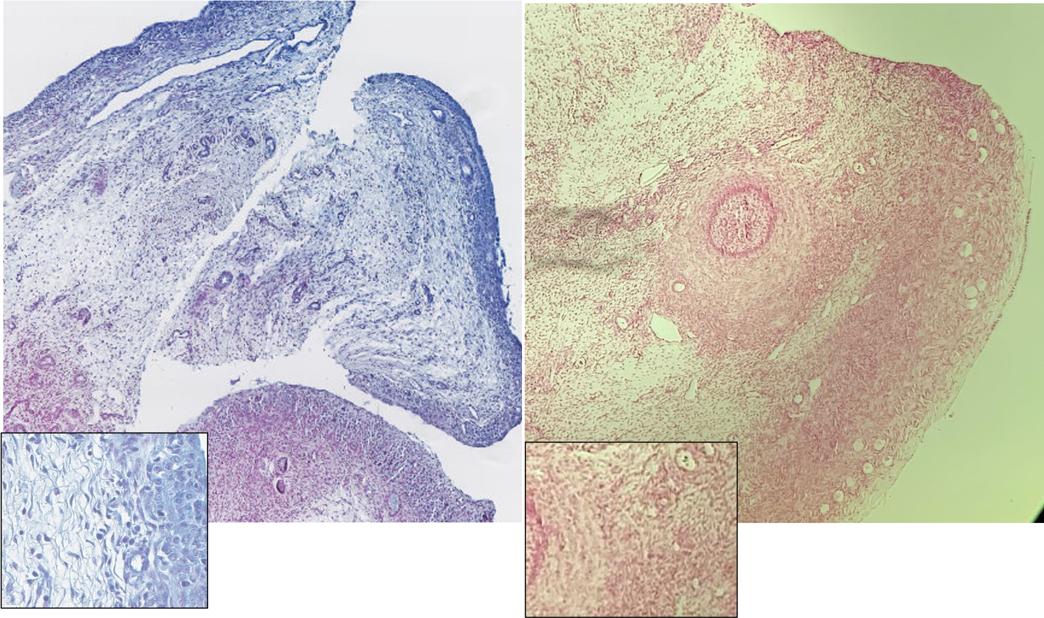
B
D
C
A
Figure 1. Iron deposition in Prussian blue iron-stained SCD patient slide (A) with magnified view (C) and absence of iron deposition in Prussian blue iron-stained control patient slide (B) with magnified view (D)

